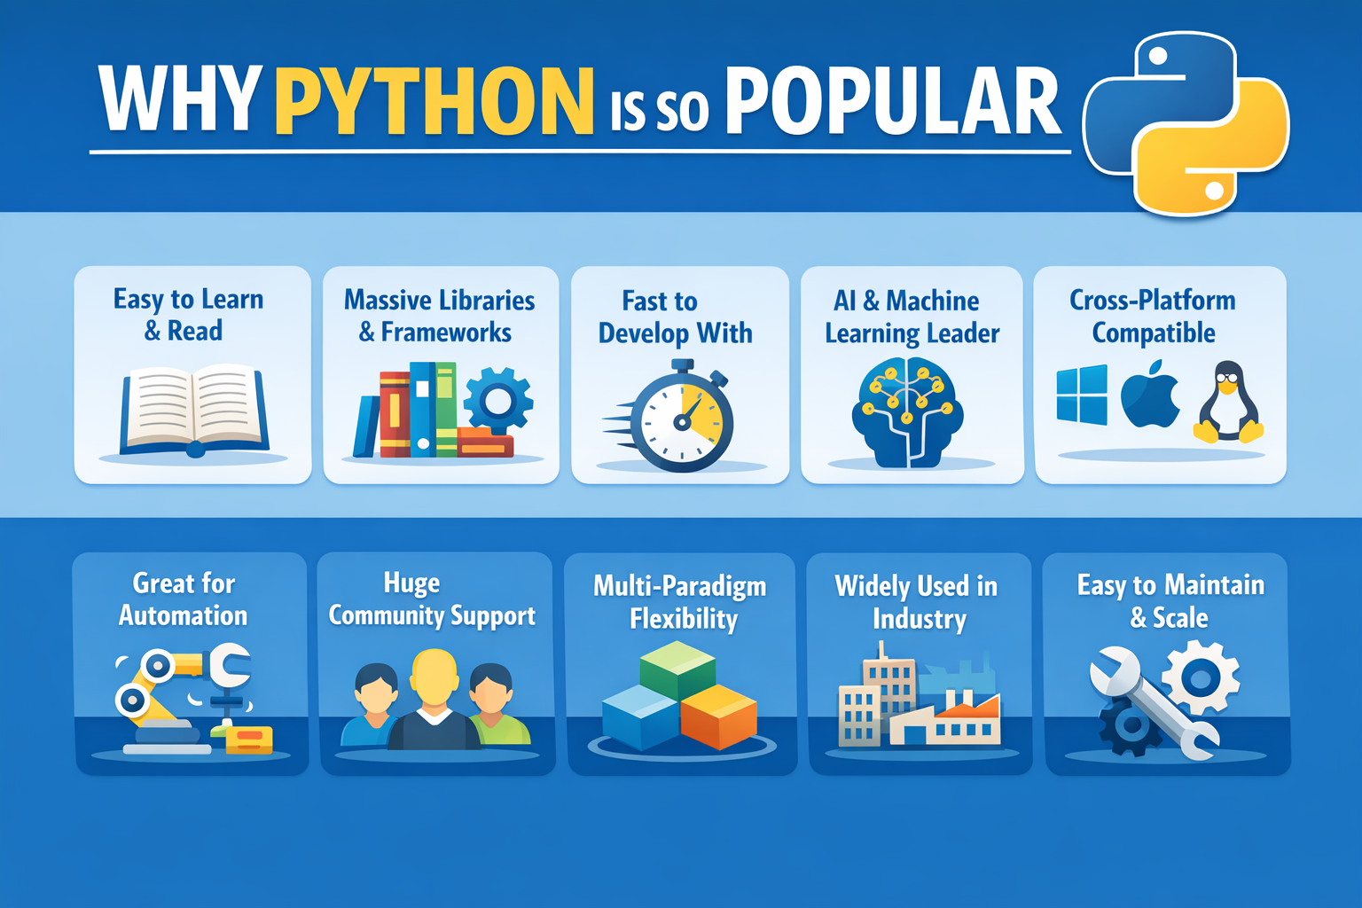

Why Python Is So Popular?
Python’s popularity is not accidental, nor is it based on hype alone. It has earned its position by consistently reducing friction for learners, professionals, and organizations across many domains. While some online articles exaggerate or oversimplify Python’s strengths, the reasons below are grounded in how Python is actually used in education and industry today.

1. Readable Syntax and Low Barrier to Entry
Python was designed to be readable and expressive. Its syntax minimizes boilerplate and emphasizes clarity, which makes it approachable for beginners and efficient for experienced developers. This readability is one reason Python is widely used as a first programming language in universities and training programs.
Importantly, readability also improves long-term maintainability. Code that is easier to read is easier to review, debug, and extend.

2. High Developer Productivity
Python is often described as “fast,” but the accurate claim is that Python enables fast development, not necessarily fast execution.
Developers can write working programs with fewer lines of code and iterate quickly without a compile step. For many organizations, reducing development time and experimentation cost matters more than raw runtime performance.

3. Massive and Mature Ecosystem
Python has one of the largest ecosystems of third-party libraries of any programming language. These libraries cover areas such as:
- Scientific computing and numerical analysis
- Data analysis and visualization
- Machine learning and artificial intelligence
- Web backends and APIs
- Automation, testing, and DevOps tooling
In many cases, Python serves as a high-level interface to highly optimized native code written in C or C++, combining usability with performance where it matters.

4. Dominant Language for Data, AI, and ML Workflows
Python is the primary language used to orchestrate data pipelines, experiments, and machine learning workflows. While the heavy computation often runs in optimized native libraries or on GPUs, Python is the glue that connects data preparation, model training, evaluation, and deployment.
This role has made Python central to modern AI and data-driven development.

5. Cross-Platform and Flexible
Python runs on all major operating systems and fits naturally into a wide variety of workflows. It is commonly used in:
- Desktop and server environments
- Cloud-based systems
- Continuous integration pipelines
- Internal tooling and automation scripts
While platform-specific dependencies can exist, Python’s portability is strong enough that many teams standardize on it.

6. Strong Community and Learning Resources
Python’s large global community is a major practical advantage. It means abundant documentation, tutorials, examples, and community support. When developers encounter problems, answers are usually easy to find.
This reduces learning time and lowers the risk of adopting the language for new projects.

7. Broad Adoption in Education and Industry
Python is taught widely in academic programs and used extensively in industry. It consistently ranks near the top of programming language popularity indices and is commonly listed as a required or preferred skill across roles in software development, data, automation, and research.
This widespread adoption reinforces itself: more users lead to more libraries, tools, and community support.

8. Excellent Language for Automation and Integration
A large portion of real-world software work involves integrating systems rather than building algorithms from scratch. Python excels at this “glue code” role, making it ideal for:
- Automating repetitive tasks
- Integrating APIs and services
- Handling files, data formats, and pipelines
This practical utility keeps Python relevant even outside traditional software engineering roles.

9. Supports Multiple Programming Paradigms
Python supports procedural, object-oriented, and functional programming styles. This flexibility allows teams to choose patterns that fit their problem domain.
The tradeoff is that teams must establish conventions and discipline; Python does not enforce a single architectural style by default.

10. Suited for Long-Term, Team-Based Development
Beyond being easy to learn, Python is well suited for long-term, collaborative software development. Its emphasis on explicit, readable code makes it easier for teams to review changes, onboard new developers, and maintain large codebases over time.
This matters in real organizations, where software often outlives its original authors. Python’s clarity reduces the cognitive load required to understand existing code, lowers maintenance costs, and makes refactoring less risky as systems evolve.
While this strength builds on Python’s readable syntax, it goes beyond beginner friendliness. It reflects how Python supports sustainable development practices in professional, team-based environments—one of the reasons it remains a popular choice for production systems.

Final Thoughts
Python remains popular because it consistently maximizes practical value. It enables rapid learning, rapid development, and effective integration across domains, all while being supported by a vast ecosystem and community.
It is not the fastest language, the most restrictive, or the most specialized—but it is often the most efficient choice when considering the total cost of building and maintaining software. That balance is why Python continues to grow in popularity year after year.

